Executive Summary Form and
Guidelines for Executive Summary Writing

This document is divided into two major sections:

Section 1 Executive Summary Form
and
Section 2 Guidelines for Executive Summary Writing

Executive Summary
Name of Program: ………………………………………...……. Faculty: ………………………
Revised round: ………….……………Semester (begins implementation): ………………………

Rationales for opening or revising the program (Choose only one)
1.1. An analysis of the situation and environment that affects the opening or revising of this programme.
………………………………………………………………………………………………………………………………………………………………………………………………………………………………………………………………………………………………………………………
1.2 The importance of the proposed revision of the programme or the launch of a new programme and the process or procedure for formulating the learning outcomes of this programme with justifications.
………………………………………………………………………………………………………………………………………………………………………………………………………………………………………………………………………………………………………………………
Programme Specification
2.1 Philosophy, importance, and objectives of the Program
………………………………………………………………………………………………………………………………………………………………………………………………………………………………………………………………………………………………………………………
2.2 Special Characteristics of the graduates of the Program
………………………………………………………………………………………………………………………………………………………………………………………………………………………………………………………………………………………………………………………
2.3 Expected Learning Outcomes
………………………………………………………………………………………………………………………………………………………………………………………………………………………………………………………………………………………………………………………

Developing Learning Outcomes and Methods of Assessment in order to develop learners to achieve learning outcomes of the Programme.
3.1 Describe strategies to improve learners' learning outcomes by demonstrating constructive alignment of PLOs/CLOs, teaching and learning approach and methods of assessment.
………………………………………………………………………………………………………………………………………………………………………………………………………………………………………………………………………………………………………………………
3.2 Stage-LOs or Year-LOs (Choose only one)
- Specify the learning outcomes in accordance with the students’ development process of the program along with the method of assessment at each stage.

Stage-LO1 …………………………………………………………………………………….
Period of Assessment …………………………………………………………………….
Methods of Assessment …………………………………………………………………….
Rubrics of Assessment …………………………………………………………………….

Stage-LO2 …………………………………………………………………………………….
Period of Assessment …………………………………………………………………….
Methods of Assessment …………………………………………………………………….
Rubrics of Assessment …………………………………………………………………….

Stage-LO3 …………………………………………………………………………………….
Period of Assessment …………………………………………………………………….
Methods of Assessment …………………………………………………………………….
Rubrics of Assessment …………………………………………………………………….

3.3 Structure of Programme
3.3.1 Comparison of the old programme structure with the announcement of the Ministry of Education regarding curriculum standards as follows:

Subject | Number of credits |  |  | Difference of  Number of credits
 | OHEC Framework | Program  25.... B.E | Revised Program  25.... B.E
- GenEd. Courses | ≥ 30
- Compulsory Courses  - Courses of ...................  - Courses of ...................  - Courses of ...................  - Courses of ................... | ≥ 72
- Elective courses | ≥ 6
Total credits | ≥ 120

3.3.2 Explain concepts in designing the program and its content that are implemented to develop learners to achieve the learning outcomes of the program.

Input Factors
Qualifications of the candidates in the program
………………………………………………………………………………………………………………………………………………………………………………………………………………………………………………………………………………………………………………………
5. Opinion of external experts and implementation of suggestions
Summary of external experts’ opinion and implementation of suggestions
Name-Last name ……………………………………………..................................…………….
Position .................................................................................................................................................
Affiliations……………………………….............................................................................................……
Expert in ....................................................................................................................................
Agree on details of the program but there are suggestions as follows:
Suggestions | Implementation of the program

Guidelines to write an Executive Summary
Section 1 Rationale for program revisions
1.1 An analysis of the situation and environment that affects the opening or improvement of this course.
- Demonstrate analysis of both external and internal environments that will be used as important information in the design of this program.
a) External environment analysis is an analysis of the overall situation or external need that affects the curriculum (situation analysis/overall need analysis).
a1) Analysis of the needs of key stakeholders related to the curriculum, including graduate users, students (current students and alumni), parents, institutional administrators, and personnel (relevant professors and employees).
- Describe the process of acquiring the needs of the program stakeholders. Selection of key stakeholder groups and representatives, including the tools, methods and time spent on the survey as well as showing the connection how the program applied the results of the survey of stakeholder needs in each issue to determine Program learning outcomes or what issues were used in the improvement of this program in any part.
- The syllabus may summarize the key points or requisites the program has chosen for this improvement which in the description can be presented in the form of an example or other formats as appropriate.
Sample
Stakeholders | Survey period | Survey Method | Survey issues | Survey Result | Program Learning Outcomes results

a2) Macro-environmental analysis, including demographics, economic, social, cultural, technological, political, policy or related legal conditions is to look for opportunities or obstacles from the external environment as well as the potential impact of these factors on the program.
a3) Competitor/Comparative Competitor analysis is to analyze who the competitor/comparator of the program is and is a final overview of what the program is like or where the program places itself, including showing the strengths that create the ability to compete.
- Programs used as a counterparty can be either a domestic or international program. The program must clearly demonstrate the strengths that differentiate and compete with other programs in the market, which can be the reasons why students choose to study in this program and employers choose graduates from this program. The comparison should be in terms of academic or student performance.
a4) Others

b) Internal environment analysis is an analysis of the current state of the organization or organization in order to find strengths, weaknesses, or what may be a major problem in operations which affects the improvement of the program and is as follows:
b1) An analysis of the program’s past performance (five years in the past), such as graduation and dropout rates of course students, duration of study in the course, employment situation of graduates, career advancement after graduation (for graduates who have jobs already), etc.
b2) Resources analysis is the analysis of existing resources of the program i.e., human resources, location/environment, tools, equipment and materials, funding, etc. The analysis should focus on the sufficiency to support the teaching and learning of the program to achieve the expected learning outcomes.
b3) SW — Analysis of the sstrengths and weaknesses from the internal environment to create differentiation and competitiveness.
b4) Others

1.2) The essence of the proposed improvement of the program or the launch of a new course and the process or procedure for determining the learning outcomes of the program with reasons.
c1) Explain and show that the analysis in Section 1.1 links to the design of the program, the improvement of the program and the determination of its learning outcomes for this revision with reasons.
c2) Show issues or things that the program has improved this time with reasons.
(e.g., reasons for course improvements, adjustments to PLOs, reductions or additions of courses/credits/study plans, adjustments to student admissions plans, modifications of teaching and learning management and assessment, etc.)
c3) Highlights of the program that differentiate itself and its ability to compete with other programs in the market. What are they? Why did students choose this program?

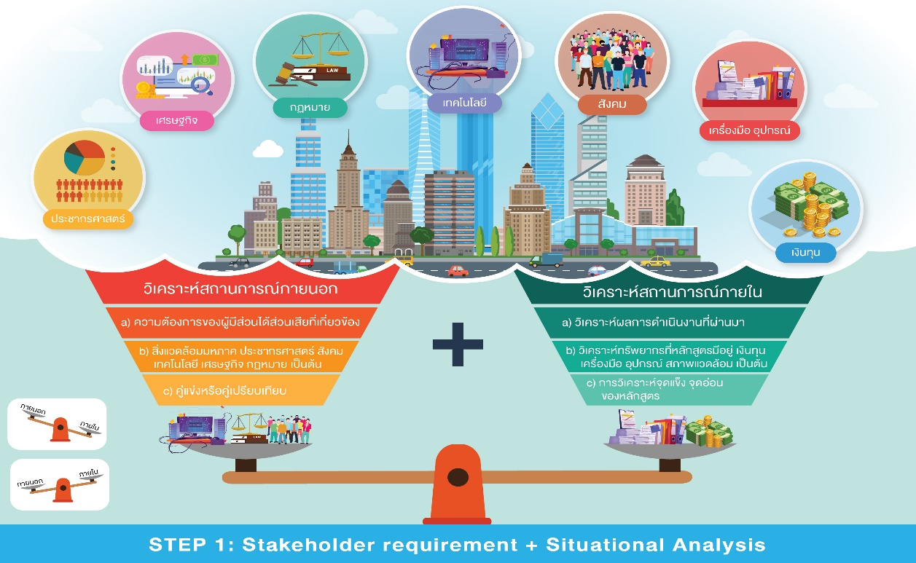

Section 2 Programme Specification
2. 1 Philosophy, significance, and objectives of the program
- State the philosophy, significance, and objectives of this program (What is this program for? Why should this program exist?) It must be consistent with the philosophy of higher education, the institution's philosophy and academic/professional standards or how to produce graduates with desired characteristics and knowledge.
- The program philosophy is essential to produce graduates, and this part of the philosophy must be related to its significance, objectives, and Program learning outcomes, teaching strategies, assessment methods, and prospective profession, which is the basic concept of Outcome Based Education (OBE).
2.2 Special characteristics of graduates from the program
- Identify the characteristics of the graduates of the program. The special characteristics should be in addition to the general expectations of the university, faculties, or departments with the aim to develop the students of this program and must be aligned with the program learning outcomes.
2.3 Expected learning outcomes of the Program
- What can graduates from this program do, what are they, and what are their characteristics?
- The program should designate PLOs that demonstrate the strengths or special attributes of graduates from the program in order to create a competitive competence.
- PLOs must be the picture of graduates from the program. Therefore, they should be appropriate for the level of education.
- A Program with several educational plans must have some mechanisms for managing each plan to ensure that all graduates from the program achieve the same PLOs or the same minimum PLOs.
- Formulating Learning Outcome must start with an Action Verb to measure what students have expressed. It should also include an extension (Qualifying phrase) to demonstrate the learner's level of competence accepted by the program.
- More instructions for formulating PLOs and Action Verbs can be found at https://drive.google.com/drive/folders/1GoFBlcq9XONpZzjT6z88KTOPtXubsw-n?usp=sharing

Section 3 Development of Learning Outcomes and Learner Assessment to make sure that learners achieve the PLOs.
3.1) Development of learning outcomes in each aspect of the curriculum
- Describe strategies to improve each learning outcome to demonstrate consistency of learning outcomes (PLOs/CLOs), teaching strategies used to improve learning and learning evaluation strategies to develop learners to achieve the results specified by the course (Constructive lignment).
- Explain teaching strategies to be used in various courses in the curriculum in order to develop learners to achieve the learning outcomes of the established curriculum by designing concepts of teaching methods and teaching activities that are consistent with the PLOs and CLOs of the curriculum.
- Explain the measurement and evaluation strategy to be used in the courses in the curriculum to assess the learning outcomes of learners whether they are able to achieve the learning outcomes of the specified curriculum or not by the concept of measuring and evaluating learners that is consistent with PLOs and CLOs. Of course, the methods of measurement and evaluation must reflect that the accuracy and reliability (the standard measure) are justified and what the strategy should be designed to measure and evaluate it from. Initial assessment during class and assessment upon graduation including a mechanism for providing timely feedback from teachers is to be used to improve learning of learners.
- Courses may be tabulated and the learning outcomes development in each aspect of the curriculum according to the example or other formats is summarized as appropriate.
Example summary table
Program Learning Outcomes | Teaching and Learning Approaches | Assessment Methods
PLO 1: …………………………….  …………………………… | ………………………………….  ………………………………….  …………………………………. | ………………………………….  ………………………………….  ………………………………….
Sub PLO1A: ................................... | ………………………………….  ………………………………….  …………………………………. | ………………………………….  ………………………………….  ………………………………….
Sub PLO1B: ……........................... | ………………………………….  ………………………………….  …………………………………. | ………………………………….  ………………………………….  ………………………………….

- Guidelines for teaching and learning approaches and assessment method can be found at https://drive.google.com/drive/folders/1oMuNBHXxzxG_OgqSrTc70sD6P7WBw-Hv?usp=sharing

3.2 Stage - LOs or Year - LOs (choose one)
- Identify learning outcomes based on the sequence of learner development that the curriculum provides along with showing how to measure and evaluate the learning outcomes at each stage.
- Stage - LOs indicate the control point or check point of the expected learning outcomes.
- Stage - LOs is a collective learning outcome that reflects the learner's competency or competence at a developmental level (from learning) and should be aligned with the CLOs of the courses that students learn in that stage.
- If the course has multiple study plans, courses can set different Stage - LOs, but the course must ensure that once students have successfully completed the course, all students are required to study a plan to achieve the same learning outcomes.
- Stage - LOs determination does not have to be set annually or per semester. Courses can be scheduled independently of time.
- Evaluation criteria for each Stage - LOs, which must be a measure of what each student has to do after passing that stage, and in the event that the student does not pass, how does the course work to get students through each stage?
- Ask the course to set Stage - LOs and specify the measurement and evaluation period, measurement and evaluation methods, and complete measurement and evaluation criteria.
You can find more instructions on how to set Stage - LOs at
https://drive.google.com/file/d/1xJAJik_F5m8ozpvxZO3Fwxc_yrpsIE9R/view?usp=sharing
Sample

Stage-LO1 ………………………………………………………………………….
Period of Assessment …………………………………………………….
Methods of Assessment …………………………………………………….
Rubrics of Assessment ………………………………………………………….

Stage-LO2 ………………………………………………………………………….
Period of Assessment …………………………………………………………….
Methods of Assessment ………………………………………………………….
Rubrics of Assessment ………………………………………………………….

3.3 Structure of Program
Subject | Number of credits |  |  | Difference of  Number of credits
 | OHEC Framework | Program  25.... B.E | Revised Program  25.... B.E
- Gen. Ed Courses | ≥ 30
- Compulsory Courses  - Courses of ...................  - Courses of ...................  - Courses of ...................  - Courses of ................... | ≥ 72
- Elective courses | ≥ 6
Total credits | ≥ 120

3.3.2) Explain the concept of design, structure and content of the program to be used in developing learners to achieve the program’s learning outcomes.
- Demonstrate the concepts in designing the structure and content of the program appropriate to the development of learners to achieve the program’s learning outcomes by demonstrating the rationale behind the structure of the program, the organization, the integration and the currency of the program.
Section 4 Input Factors
Qualifications of the students
- Identify the desired attributes and qualifications of the students set by the program. These expected qualifications and desired attributes of the students must be sufficient to enable the learner to graduate in accordance with the designed program.
- Attributes and qualifications of students can be written separately according to the requirements of each study plan.

Section 5 External experts’ opinion and implementation of recommendations
Opinion of external experts and implementation of recommendations
- Summary of opinions from external experts and implementation of recommendations.
- Comments from external experts and the implementation of all recommendations again. Please make it clear that if there are adjustments, where the adjustments to make are and how it has been revised. Report only on the part that reflects the quality of teaching and learning in the program. However, the program implementation must be consistent with the recommendations of external experts.
Name-Last name ……………………………………………..................................…………….
Position .................................................................................................................................................
Affiliations……………………………….............................................................................................……
Expert in ....................................................................................................................................
Agree on details of the Programme but there are suggestions as follows:
Suggestions | Implementation of the Programme

